Image | 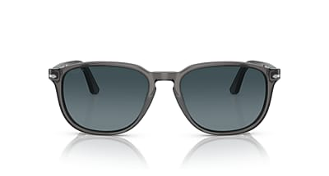
Brand | OLIVER PEOPLES
Model Name | PO3019S
Price | RS 3399
PRODUCT DETAILS

